Assignment-I

1. A small office with a total of 35 employees. Each falls in a different salary bracket based on their no. of industry experience and educational background. The distribution table with the salary information is given below. Determine the skewness of the salary distribution based on the provided information.

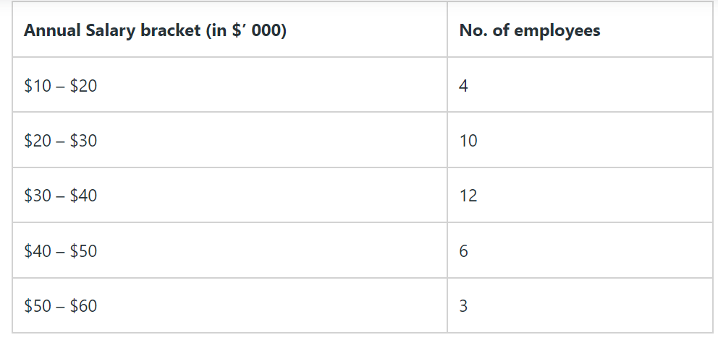

1. Find out Kurtosis type for given data Y= **42, 20, 38, 78, 54, 26**
2. A student recorded his/her scores on weekly R programming quizzes that were marked out of a possible 10 points. His/Her scores were as follows:

8, 5, 8, 5, 7, 6, 7, 7, 5, 7, 5, 5, 6, 6, 9, 8, 9, 7, 9, 9, 6, 8, 6, 6, 7

What is the mean, median and mode of his/her scores on the weekly R programming quizzes?

1. Suppose the speed of quaint weather events has a population that is normally distributed with a standard deviation of 8. One day you sample 44 quaint weather events from this population and obtain a mean speed of 5.4 and a standard deviation of 7.3023. Using an alpha value of α = 0.05, is this observed mean significantly greater than an expected speed of 3?
2. For your first year project you sample the piety of 74 far-flung Americans from a population and obtain a mean piety of 96.43 and a standard deviation of 4.7922 . Using an alpha value of α = 0.01, is this observed mean significantly greater than an expected piety of 95? What is the effect size? Is the effect size small, medium or large?
3. One day you sample the knowledge of 31 utopian dinosaurs from a population and obtain a mean knowledge of 45.64 and a standard deviation of 7.407 . Using an alpha value of α = 0.01, is this observed mean significantly less than an expected knowledge of 50? What is the effect size? Is the effect size small, medium or large?
4. Soil temperature (x , in C) and germination interval (y , in days) were observed for winter wheat at 10 localities:

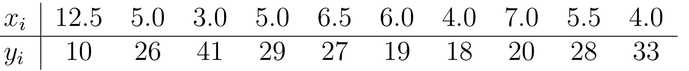

Find the Correlation Co-efficient